THE ECOLOGICAL FOOTPRINT OF BERLIN (GERMANY)
FOR THE YEAR 2000

by Jens Pacholsky (MSc).

The study was conducted as the thesis
for an MSc in Environmental Management at
Stirling University, Scotland
(under supervision of Dr. Ian Moffatt)

Introduction and brief explanation of the methodology and its modifications

This study examines the ecological footprint (EF) of Berlin, Germany for the year 2000. Ecological footprints are a measure of humanities dependence on natural resources, for both the production of goods and the assimilation of waste. EFs provide cedible, comprehensive, concise, detailed and scalable data. In 1999 the world’s average EF was 2.3 global hectares (5.6 acres), or 20 percent over the current capacity, the average German’s EF was 4.7 global hectares (12 acres, 2.6 times over its capacity), and the average American’s EF was 9.6 global hectares (24 acres, 1.6 times its current capacity) (Redfining Progress, 2002).

The general assumptions, terms and methodology used in this study are based on those described by Wackernagel and Rees (1996); Wackernagel, Chambers, Simmons (2000) and the website http://www.newsociety.com/. This study, differs to the "normal Wackernagel / Rees" approach in that it not only includes the pure EF calculation but also a comparison of different data sources. In particular, the use of global average values (as referred to in most of the EF calculations conducted by Wackernagel et al.) versus the use of more specific, regional data regarding embodied energy (EE) of goods, CO₂ emission rates and CO₂ assimilation rates.

Berlin – a metropolis and capital city

Berlin, Germany’s capital, lies in the centre of Middle-Europe (52°31'12" North, 13°24'36" East) within the temperate ecozone (see map on page 5). Shortly after Germany’s re-unification in 1990. Berlin was re-appointed as the German capital and the German Government moved from Bonn to Berlin.

Many large, fast-tracked and ambitious developments took place in the 1990’s leading to Berlin’s title as "Europe's biggest construction site". The outcome was a rapidly changing Berlin and the bankruptcy of the Berlin government in 2001. Proposed developments mainly concentrated on Berlin as a financial centre and economic magnet. The environment was considered through the 1979 law for Nature Protection and the 1994 amended Landschafts Programm (Landscape program) (SfUD, 2002b).

Berlin represents a special case of a city since it is also a Land (state) in its entirety. This implies a strongly restricted supply-area (overall only 89,141 ha), and a high density of activities, highlighted by the results of this paper. In fact, Berlin can not expand without exceeding its political boundaries. It must develop.

In 2000, 3.3 million people lived in Berlin. Its economy was mainly based on high-tech industries, pharmacy, biotechnology, environmental and information technology, as well as the increasingly important tertiary sector. This economic characteristic forms a typical pattern with the tertiary sector mainly based in the centre of Berlin, while 95 percent of industrial and business-used built-land is allocated along or outside the S-Bahnring (suburban railway ring), which encloses the city centre (SfUD, 2002b). Many buildings within the city centre are multiple-use, for housing and businesses. Outside the S-Bahnring the multiple use pattern diminishes and a rather clear distinction is made between housing and business in form of shopping centres etc. The industrial sector has been declining over the last decade and a shift to a tertiary sector based economy has taken place.

Berlin faces enormous pressure from private traffic. The well developed road system offers citizens the ability to reach any destination by car, whilst inner-city constructions (narrow roads with adjacent high-rise buildings) challenges environmental and public health issues. The public local transport network is well developed - probably one of the best developed public transport infrastructures in existence - but faces price problems, which shifts many public transport users to private transport alternatives (SfUD, 2002a). Traffic problems are projected to increase due to sub-urbanisation, a movement in "garden cities", general isolated from public transport systems and economic infrastructure. This trend appears throughout Europe (Schoonbródt, 1995, p.68).

Data Input and Modifications of Ecological Footprint methodology

Modifications used in this study were predominately based on sources of data input and basic data different from Wackernagel's approach. These changes in value assumptions and data sources were necessary for reasons explained below.

Data Input
Table 1 identifies the main components considered in this study.

Table 1: Ecological Footprint Components

Components
Built-land (housing & free spaces) | Water supply and waste water
Energy (household, unspecified) | Biodiversity
Food (plant-based, animal-based, sea-based) and wood | Greenhouse Gases
Traded-good consumption (EE¹ of goods, industrial area; energy use of energy processing sector, business) | Interpolation of Wackernagel values for processing and transport of food
Traffic (road, air, public transport, water) | Supply area (Biocapacity)
Waste (recycled, landfill, incinerated)
Notes: 1. EE – Embodied energy

Built Land (usage as a percentage of Berlin’s total area):
  - 36.2 percent housing and free spaces
  - 30.1 percent green spaces of which 51.5 percent were woods
  - 13.9 percent traffic
  - 6.6 percent water
  - 4.0 percent industry and business
  - 3.3 percent unspecified

Energy use and related exploitation of different energy sources was taken from the exhaustive statistics of the Berlin Energy Balance. Berlin’s energy is almost entirely sourced from non-renewable sources - mineral fuel (42 percent), coal (28 percent) and gas (25 percent). Less than one percent of Berlin’s energy comes from renewable resources. The CO₂ emission rate per Terajoule (TJ) of energy for the Berlin-specific fuel mix was calculated to be an average of 83,221 kg of CO₂ per TJ (minimum: 80,456 kg/TJ, maximum: 85,986 kg/TJ).

The food EF was calculated on the basis of the import-export statistics and average food consumption figures. The statistics distinguished between import countries, which made a country-specific EF calculation possible for every food item. Consequently, a quite exact footprint calculation of food items was attained. The same data was available for wood consumption.

Traded-good data was taken from import-export sheets, German average consumption figures on durables, as well as the registration numbers of new cars. While Wackernagel (1996) uses global average embodied energy data for durables, this study used EE data from the Institute of Applied Ecology (IAE) which provides a huge range of EE for rather modern technology production. As roughly 97 percent of Berlin’s durable imports come from within Europe and Germany itself, a relatively high technology standard was assumed. This also implied the use of the average CO₂ emission rates for the European Union (EU) grid (0.2 t CO₂ per GJ) given by Wackernagel et al. (2000).

The use of more distinct EE values was necessary since the EE calculation of the Berlin with Wackernagel's (1996) global average EE values led to negative overall energy figures for the industry sector, something which is thermodynamically impossible. And since the range of EE values and emission rates vary strongly on a global scale, it is important to achieve an exact localisation of sources.

The traffic footprint was based on the emission register of on an exhaustive traffic census conducted in 1998/99 as well as the energy balance. The distinction between diesel and fuel engines gave very accurate figures including a distinction between private and public transport.

Calculation of the waste footprint required by far the largest amount of data since values were available for domestic waste, industrial and business waste, bulk waste, street waste, construction waste and special waste, subdivided into recycled, incinerated and disposed. The 1999 waste analysis gave detailed information about the composition of domestic waste. EE was taken from the IAE and the Tellus Institute. The emission rate for incineration was provided in the energy balance.

Water supply and wastewater treatment footprints were taken from the statistics of the Berlin water plants including a leakage rate of 7.4 Mm³. The EE of wastewater treatment was taken from the data used in the Liverpool EF Report.

Biodiversity contributed 12 percent of the overall EF as recommended by WCED in 1987.

Green House Gases were taken from the UNFCCC GHG Inventory of Germany 2000 which gave approximate figures per capita. Since Lenzen et al. (2001) provided conversion factors for GHG to CO₂ equivalents, an approximate GHG EF figure was calculable. Because of the uncertainty of the approach, the EF component was calculated separately and not included in the final EF figure.

Wackernagel (2000, p.89) provided aggregated figures for EE of food including agricultural area, processing and transport. The figures suggested an area appropriated by transport and processing 1.5 - six times higher than the agricultural area. This figure was applied to the food calculation by multiplying the food area by a mean of 3.5. The derived figure is included separately in the overall EF, but has to be considered as overestimated since it exceeds the sum of 'energy-use', 'traffic' and 'traded-goods'. Wackernagel (2000, p.89) does not provide sources of this calculation.

The CO₂ assimilation rates – a crucial value

The use of appropriate assimilation rates is a crucial point in the EF calculation procedure. CO₂ assimilation rates convert the impact of waste, traded-goods, energy and traffic - in this study contributing 71 percent to the overall EF - to their required EF areas. Even slight changes in these values can alter the outcome. Wackernagel et al. (1996) offer two options for assimilation rates:

- 100 GJ of energy /ha*yr. This approach totally leaves out any differences in emission rates, therefore equalising the emissions of different energy sources like non-renewable and renewable resources. This is an approach most unlikely to be representative.
- 5.26 tCO₂ / ha*yr. This is a global average figure.

Since Berlin's impact is mainly restricted to Europe (97 percent of imported traded goods come from Europe) and the large-distance transport of the rather non-inert CO₂ compound is unlikely, this study used the minimum assimilation rate for the temperate ecozone of 7.2 tCO₂ / ha*yr as given by Schultz (1995). Consideration of different assumed assimilation rates is important because their use achieves very different EF figures (see Table 2).

Table 2: Comparative Use of Different CO₂ Assimilation Rates
Approach | EF [ha/cap] | Assimilation Rate
Current Study | 4.06 | 7.2 tCO₂/ha/yr
Global average values I | 9.0 | 100 GJ/ha/yr
Global average values II | 12.3 | 5.26 tCO₂/ha/yr

Berlin lives far beyond its boundaries

The calculated EF for Berlin for the year 2000 was 4.06 ha/cap, which is below the 1999 German total of 4.7ha/cap (Redefining Progress 2002). As can be seen in Figure 1 below, waste and traded-goods made up more than 50 percent of the total EF for Berlin. This is important since both components are strongly interlinked. Water appears as zero percent because of its contribution (less than half a percent). This study did not apply the conversion factors for global scale as recommended by Wackernagel et al. (1996). They suggest the conversion of regionally required bioproductive hectares (the EF itself) to global bioproductive hectares since even a local economy is at least partly globalised and therefore uses land worldwide. This study showed that about 90 percent of Berlin’s food comes from Germany, the remaining 10 percent mainly from the Netherlands, and 97 percent of imported durables come from within Europe. Therefore, the EF remains continental rather than global. A globalisation of CO₂ is hardly applicable. However, the application of global conversion factors would double the EF to 9.02 ha/cap.

Figure 1 – Ecological Footprint Berlin
Compared with its supply or biocapacity of 0.05 ha/cap, Berlin exceeds the supply area by about 82 times. Just as London requires an area twice the size of the UK mainland, Berlin's footprint is as large as the eastern part of Germany, or 12.8 Mha (see shaded area on Figure 2 below).

Figure 2 – Berlin’s Footprint
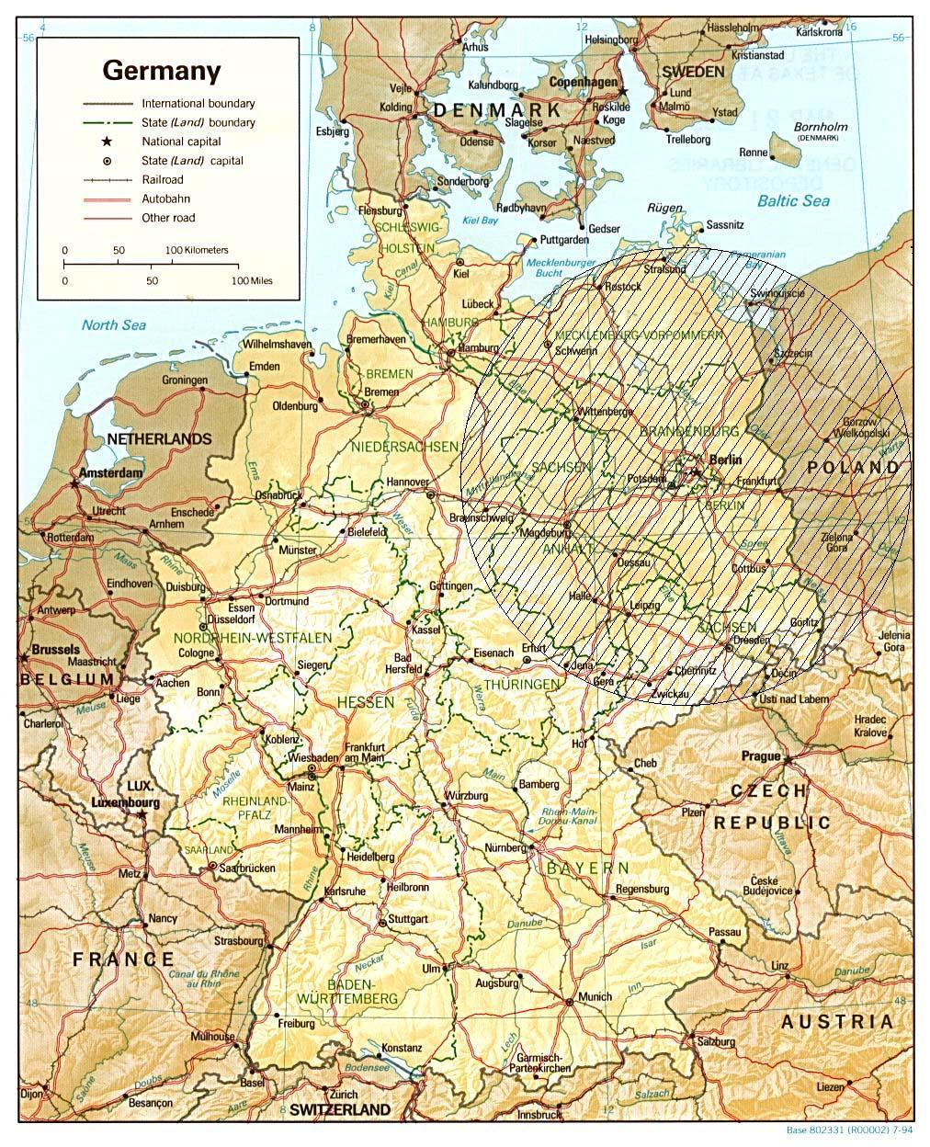

What can we do about it?

Management solutions are not as simple as councils often present them. To tackle environmental problems in big cities it is not enough to merely dig out common solution concepts such as recycling rates, waste incineration and an increase in public transportation. Management becomes a psychological, social and educational task.

A prognosis for different types of waste management solutions (increase in recycling rate, theoretical reduction of waste output) showed that the effect would be rather small regarding the waste component itself. Since the recycling rate in Berlin, depending on the waste compound, is between 70 percent and 95 percent (construction waste), there is not much room left to increase the efficiency of that solution. The increase of the recycling rate mainly affected the traded-good section since virgin materials were saved by use of recycled materials.

However, it is important to understand material flows and interrelation between consumption and waste production and the psychology behind it, particularly regarding advertisement and furthermore packaging psychology. Although the EU has published a Directive on Packaging which is supposed to decrease packaging to a necessary minimum, the trend of small-size products like "food pocket-packets" or single-product packaging takes place throughout the economy and tries to persuade the consumer with its practicability as a snack etc. Just as the reason for that trend is a pure economic-psychological one, the solution has to be psychological-educational and not purely technological. Furthermore, the basis of this problem is the new economy's genuinely accepted (mis-) concept of "supply creating its own demand".

This also counts for the problem of traffic. Berlin, as a big city, has one of the best public transport systems but still the streets are chocked by cars every day and the inner city looks like a huge parking place at night. The enhancement and widening of roads is reactive rather than proactive. The psychology of car-driving is still unbroken or tightened by delays, security problems and increased ticket prices in the public transport system.

There also is a good public transport connection for commuters, which is now stressed by the trend of suburbanisation - the creation of housing estates which are not connected to any public transport system except a single road to the motorway which leads into the city. Both, the concept of suburbanisation and the final planning of this development have generally been unquestioned.

About six percent of the EF is contributed by energy-use of households and businesses of the tertiary sector. As noted above, Berlin's fuel-mix for energy production is based on non-renewable resources (see Table 3). The share of renewable resources is less than one percent. A change in fuel-mix composition is a crucial step in decreasing the energy's EF, additional to a reduction in energy use in public buildings (advertisement lighting, night lighting) and private households.

A fuel-mix change to 40 percent natural gas and 30 percent wind energy (mineral oils used for road transport account for the remaining 30 percent) would result in a reduction of the energy EF of households and businesses by 30 percent. Applied to the industry sector, which contributes 25 percent to the overall EF, a fuel-mix change might have an even greater positive impact. Nevertheless, more research is required to identify which form of renewable energy is most valuable for the Berlin area, since wind energy cannot be applied under inefficient climatic conditions.

Table 3: Energy Use and Energy Resource Use of Berlin
Resource | Terajoule (TJ) | percent of  primary use | percent of  end-use
Hard coal | 81,805 | 24.6
Brown coal | 12,601 | 3.8
Other solid resources | 3,304 | 1.0
Mineral oils | 1,38,869 | 41.8
Gases | 82,746 | 24.9
Energy exchange balance | 13,060 | 3.9
Overall | 332,384 | 100
Use & loss in energy sector | 64,401 | 19.4
Non-energy use | 3,670 | 1.1
End-use of energy | 264,313 | 79.5 | 100
Industry | 18,736 |  | 7.1
Traffic | 71,642 |  | 27.1
Domestic | 59,435 |  | 22.5
Business | 53,906 |  | 20.4
Unspecified | 60,594 |  | 22.9

Overall, environmental protection and policy is not only a technological option or a pure political question but almost entirely a personal task of selective consumption, conscious living, education and participation in environmental issues everyday. Since the politicians as well as the economy only react to the direct actions – election and purchase, respectively – of the interested individuals, the individual has to take its chance to create the demand of environmental implementations in the political landscape and economy.

Abbreviations

Abbreviation | Full Text
cap | Capita
EE | Embodied Energy
EF | Ecological Footprint
EU | European Union
GHG | Greenhouse Gases
GJ | Giga-joule
ha | Hectares
IAE | Institute for Applied Ecology
Mha | Mega-hectares
Mm | Mega-metres
TJ | Tera-joule
UNFCCC | United Nations Framework Convention on Climate Change
WCED | World Commission on Environment and Development

References

Wackernagel M and Rees W, 1996 Our Ecological Footprint: Reducing Human Impact on the Earth New Society Publishers http://www.newsociety.com

Wackernagel M, Chambers N, Simmons C, 2000 Sharing Nature’s Interest. Ecological Footprints as an Indicator of Sustainability Earthscan London http://www.earthscan.co.uk/

SfUD (Senate for Urban Development, Berlin) , 2002b Berlin – Landschaftsplanung Handbuch (Berlin Handbook of Landscape Development) SfUD, www.stadtentwicklung.berlin.de/umwelt/landschaftsplanung/handbuch/ (last access June 2003)

SfUD, 2002a Nahverkehrsplan 2000/2001 und 2004 (Local Traffic Plan) SfUD http://www.stadtentwicklung.berlin.de/verkehr/nahverkehrsplan/ (last access June 2003)

Schoonbródt, 1995 The Sustainable City – A European Tetralogy, Part II – The SMEs and Revitalisation of the European Cities European Foundation for the Improvement of Living and Working Conditions, p.68

Senate for Economy and Technology, Berlin 1999 Berlin Energy Balance www.berlin.de/home/Land/SenWiTech/energie/index.html(last access March 2002)

Lenzen M Murray SA 2001 A modified ecological footprint method and its application to Australia Ecological Economics 37 (2001), p.229-255

Barret J. and Scott A 2001 An Ecological Footprint of Liverpool – Developing Sustainable Scenarios www.york.ac.uk/inst/sei/footprint/liverpool.html (last access June 2003)

Schultz J, 1995 Die Ökozonen der Erde (The Ecozones of the World) Eugen Ulmer Stuttgart

European Union (EU) The EU Packaging and Packaging Waste Directive (94/62/EC) http://www.europen.be/issues/issues.html#1 (last access June 2003)

Redefining Progress 2002 Ecological Footprint Accounts: Moving Sustainability From Concept To Measurable Goal http://www.redefiningprogress.org/programs/sustainability/ef/efbrochure.pdf (last access June 2003)

Institute for Applied Ecology (IEA) http://www.oeko.de/oeko_en/indexb_en.html

Tellus Institute http://www.tellus.org/

United Nations Framework Convention on Climate Change (UNFCCC) http://unfccc.int/

