S o u t h I n d i a
____________________________________________________________________________________________________
C R E D
Centre for Rural Education and Development
______________________________________________________________________________________________________
A case study: CRED successful micro-credit strategy for the empowerment of rural village women in Madurai district
By Valentina Dall’Olio

• CRED
• Micro-credit and women empowerment
• SHGs members as Privileged Development Promoters
• Mrs.Rajasulochana’s story
• Conclusion: author report as CRED Volunteer
• Contact CRED and author

CRED

The Centre for Rural Education and Development is a woman headed non-governmental organization working since 1987 in the district of Madurai. Pioneer in the introduction of micro-credit strategy in the project area, CRED has always focused its activities mainly on women empowerment and has, by far, organized 650 Self Help Groups.
The creation of economic sustainable micro-enterprises is, however, only the starting point! Selected SHGs women are further involved in multi sector activities and elected as privileged promoters of development all around the target area.

Micro-credit and women empowerment

The introduction of SHG concepts and practices in Madurai rural area met many difficulties because of Indian male-dominated social contest. Strong cultural prejudices, shared by women themselves, charged them only with the tasks of housekeeping, cooking, taking care of children and husband. Micro-credit and SHGs implemented by CRED changed radically this asset.

The success in itself of their working activities is in fact only a part of the benefits gained. Family income is obviously increased but what needs to be stressed is that women have improved their entrepreneurial attitude, have acquired financial skills and have absorbed a systematic way of thinking according to long-term planning that can be applied also to non economic areas. They have started meeting regularly thus improving their communication skills: exchanging among themselves experiences and opinions raises their cohesiveness and strength. Through the small elections held to choose SHG leaders, who prefer to call themselves animators to avoid hierarchical assets, women are encouraged to expose their ideas and initiatives thus making the first steps to the development of political know-how. They gain self-esteem, respect and visibility in their family and in society as a whole.

SHGs members as privileged Development Promoters

Micro-credit is only the starting point! CRED had developed further its possible benefits. Some women belonging to SHGs are selected to receive specific training or attend workshops on various development issues: gender awareness, health, human and Child rights and education. They will have to spread the concepts acquired to all the other SHG members. Relevant knowledge about welfare topics will therefore finally reach all family members and, therefore, society. Women are chosen as privileged target of such training because they are clearly more motivated and efficient in the info-exchange process than men.
Moreover women are also involved into activities that go far beyond conducting their micro-enterprises: they are called for ACTION. Once they start empowering through SHGs some of them decide spontaneously to be in charged of tasks concerning Education and Family issues.
CRED set up crèches and non-formal education centers in Madurai area and SHG women, together with trained teachers, are those who take the responsibility of monitoring the project and offering to the 1,250 children involved daily assistance, motivation inputs and serene atmosphere.
Moreover the Centre for Rural Education and Development organized two Family Counselling Centers in Madurai. SHG members give their full collaboration to CRED staff to deal with family disputes and teach women their right to express openly difficulties and needs.
Micro-credit and SHGs are clearly showing women potential as collective actors of self and society development.

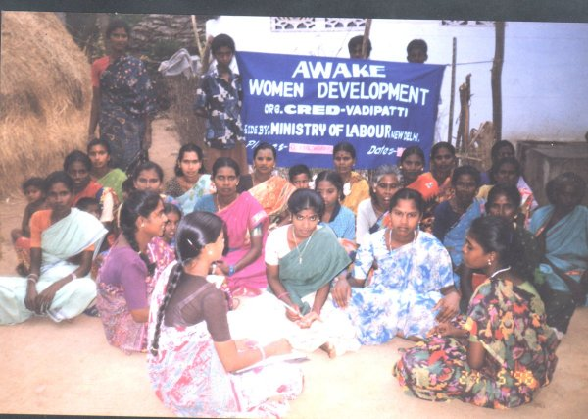
VADIPATTI
AWAKE WOMEN DEVELOPMENT : TRAINING TO
SHG’S WOMEN

Mrs.Rajasulochana’s story

In 1997 CRED promoted SHG practices to the village of Kondayampatti enlightening the possible benefits of micro-credit strategy. Mrs.Rajasulochana decided, thereafter, to set up a Self Help Group with other 19 village members. At that time she was 30 years old, married to a farmer and doing full time housewife, taking care of their two children: a 9 years old girl and a 7 years old boy. The working activity she chose was tea stall.
TBF, thanks to CRED mediation, released to the group a loan of 1 lakh Rupees to be followed after 6 months by a second equal loan. Due to the success of the SHG’s practices the Government awarded this group as best SHG of Tamil Nadu with a revolving fund of Rs.25,000 (Rs.10,000 as subsidy). Other 3 lakhs Rupees were given the group by the same source because of their repayment performances so that each member could afford two milch animals.
Now Mrs. Rajasulochana is saving each month 3,500 Rupees thanks to her tea stall and milk selling activities and has proved to be a successful Entrepreneur.
The first step was to build a new house for her family, whose registration act has been signed by both her and her husband, which is an unusual practice in India. On a strictly personal level she decided to have no more children and to concentrate her efforts for her daughter and son’s future. She would like to guarantee them high-level education according to their personal attitude and interests.
Moreover Mrs.Rajasulochana has been recently elected member of Kondayampatti Panchayat and, if asked about her ambitions, is going to promote in her capabilities welfare initiatives for the needy people in her village.

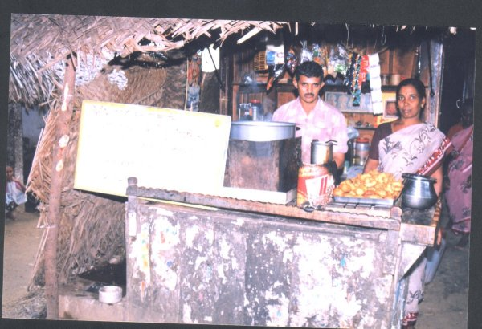
Kondayampatti Village
Mrs.Rajasulochana conducting her tea stall activity: a successful example of women Entrepreneurship

Conclusion: author report as CRED volunteer

Coming from Italy to gain practical experience about micro-credit and women empowerment in the Indian contest, I was soon positively surprised by the results of my research activity. I had the opportunity to sit among SHGs’ women and asked them how their life had concretely changed in the past years. Through their smiling faces, pride attitude and energetic answering I could have no doubts anymore: micro-credit has improved their self-awareness and social status opening a great variety of opportunities for their further empowerment! Micro-credit is giving women the chance to change their own perception and the perception society has of them. But we must remember that economic success is only a tool: woman has an enormous value in herself and not in how much she is able to get. CRED is surely contributing to the spreading of this assumption.

Contact CRED

CENTRE FOR RURAL EDUCATION AND DEVELOPMENT
301, Main Road
T. Vadipatti- 625218
Madurai District, Tamilnadu, India.
Phone: 91+4543-54453 (office)
91+4543-54314 (residence)
E-mail: cred@sancharnet.in
cred@eth.net
website: www.credindia.org

Contact Author: Dall’Olio Valentina; e-mail address: valentinadallolio@yahoo.it

