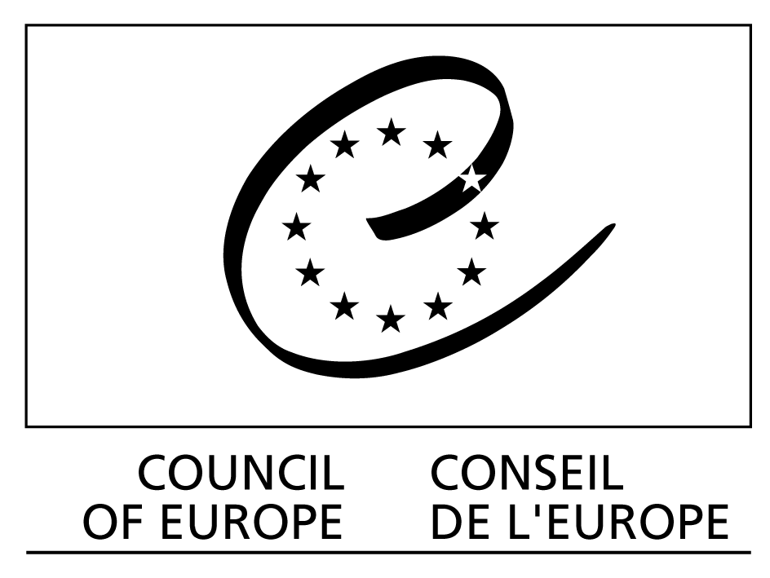

European Treaty Series - No. 121

CONVENTION
FOR THE PROTECTION
OF THE ARCHITECTURAL HERITAGE
OF EUROPE

Granada, 3.X.1985

The member States of the Council of Europe, signatory hereto,

Considering that the aim of the Council of Europe is to achieve a greater unity between its members for the purpose, inter alia, of safeguarding and realising the ideals and principles which are their common heritage;

Recognising that the architectural heritage constitutes an irreplaceable expression of the richness and diversity of Europe's cultural heritage, bears inestimable witness to our past and is a common heritage of all Europeans;

Having regard to the European Cultural Convention signed in Paris on 19 December 1954 and in particular to Article 1 thereof;

Having regard to the European Charter of the Architectural Heritage adopted by the Committee of Ministers of the Council of Europe on 26 September 1975 and to Resolution (76) 28, adopted on 14 April 1976, concerning the adaptation of laws and regulations to the requirements of integrated conservation of the architectural heritage;

Having regard to Recommendation 880 (1979) of the Parliamentary Assembly of the Council of Europe on the conservation of the European architectural heritage;

Having regard to Recommendation No. R (80) 16 of the Committee of Ministers to member States on the specialised training of architects, town planners, civil engineers and landscape designers, and to Recommendation No. R (81) 13 of the Committee of Ministers, adopted on 1 July 1981, on action in aid of certain declining craft trades in the context of the craft activity;

Recalling the importance of handing down to future generations a system of cultural references, improving the urban and rural environment and thereby fostering the economic, social and cultural development of States and regions;

Acknowledging the importance of reaching agreement on the main thrust of a common policy for the conservation and enhancement of the architectural heritage,

Have agreed as follows:

Definition of the architectural heritage

Article 1

For the purposes of this Convention, the expression “architectural heritage” shall be considered to comprise the following permanent properties:

1 monuments: all buildings and structures of conspicuous historical, archaeological, artistic, scientific, social or technical interest, including their fixtures and fittings;

2 groups of buildings: homogeneous groups of urban or rural buildings conspicuous for their historical, archaeological, artistic, scientific, social or technical interest which are sufficiently coherent to form topographically definable units;

3 sites: the combined works of man and nature, being areas which are partially built upon and sufficiently distinctive and homogeneous to be topographically definable and are of conspicuous historical, archaeological, artistic, scientific, social or technical interest.

Identification of properties to be protected

Article 2

For the purpose of precise identification of the monuments, groups of buildings and sites to be protected, each Party undertakes to maintain inventories and in the event of threats to the properties concerned, to prepare appropriate documentation at the earliest opportunity.

Statutory protection procedures

Article 3

Each Party undertakes:

1 to take statutory measures to protect the architectural heritage;

2 within the framework of such measures and by means specific to each State or region, to make provision for the protection of monuments, groups of buildings and sites.

Article 4

Each Party undertakes:

1 to implement appropriate supervision and authorisation procedures as required by the legal protection of the properties in question;

2 to prevent the disfigurement, dilapidation or demolition of protected properties. To this end, each Party undertakes to introduce, if it has not already done so, legislation which:

a requires the submission to a competent authority of any scheme for the demolition or alteration of monuments which are already protected, or in respect of which protection proceedings have been instituted, as well as any scheme affecting their surroundings;

b requires the submission to a competent authority of any scheme affecting a group of buildings or a part thereof or a site which involves

– demolition of buildings

– the erection of new buildings

– substantial alterations which impair the character of the buildings or the site;

c permits public authorities to require the owner of a protected property to carry out work or to carry out such work itself if the owner fails to do so;

d allows compulsory purchase of a protected property.

Article 5

Each Party undertakes to prohibit the removal, in whole or in part, of any protected monument, except where the material safeguarding of such monuments makes removal imperative. In these circumstances the competent authority shall take the necessary precautions for its dismantling, transfer and reinstatement at a suitable location.

Ancillary measures

Article 6

Each Party undertakes:

1 to provide financial support by the public authorities for maintaining and restoring the architectural heritage on its territory, in accordance with the national, regional and local competence and within the limitations of the budgets available;

2 to resort, if necessary, to fiscal measures to facilitate the conservation of this heritage;

3 to encourage private initiatives for maintaining and restoring the architectural heritage.

Article 7

In the surroundings of monuments, within groups of buildings and within sites, each Party undertakes to promote measures for the general enhancement of the environment.

Article 8

With a view to limiting the risks of the physical deterioration of the architectural heritage, each Party undertakes:

1 to support scientific research for identifying and analysing the harmful effects of pollution and for defining ways and means to reduce or eradicate these effects;

2 to take into consideration the special problems of conservation of the architectural heritage in anti-pollution policies.

Sanctions

Article 9

Each Party undertakes to ensure within the power available to it that infringements of the law protecting the architectural heritage are met with a relevant and adequate response by the competent authority. This response may in appropriate circumstances entail an obligation on the offender to demolish a newly erected building which fails to comply with the requirements or to restore a protected property to its former condition.
Conservation policies

Article 10

Each Party undertakes to adopt integrated conservation policies which:

1 include the protection of the architectural heritage as an essential town and country planning objective and ensure that this requirement is taken into account at all stages both in the drawing up of development plans and in the procedures for authorising work;

2 promote programmes for the restoration and maintenance of the architectural heritage;

3 make the conservation, promotion and enhancement of the architectural heritage a major feature of cultural, environmental and planning policies;

4 facilitate whenever possible in the town and country planning process the conservation and use of certain buildings whose intrinsic importance would not warrant protection within the meaning of Article 3, paragraph 1, of this Convention but which are of interest from the point of view of their setting in the urban or rural environment and of the quality of life;

5 foster, as being essential to the future of the architectural heritage, the application and development of traditional skills and materials.

Article 11

Due regard being had to the architectural and historical character of the heritage, each Party undertakes to foster:

– the use of protected properties in the light of the needs of contemporary life;

– the adaptation when appropriate of old buildings for new uses.

Article 12

While recognising the value of permitting public access to protected properties, each Party undertakes to take such action as may be necessary to ensure that the consequences of permitting this access, especially any structural development, do not adversely affect the architectural and historical character of such properties and their surroundings.

Article 13

In order to facilitiate the implementation of these policies, each Party undertakes to foster, within its own political and administrative structure, effective co-operation at all levels between conservation, cultural, environmental and planning activities.
Participation and associations

Article 14

With a view to widening the impact of public authority measures for the identification, protection, restoration, maintenance, management and promotion of the architectural heritage, each Party undertakes:

1 to establish in the various stages of the decision-making process, appropriate machinery for the supply of information, consultation and co-operation between the State, the regional and local authorities, cultural institutions and associations, and the public;

2 to foster the development of sponsorship and of non-profit-making associations working in this field.

Information and training

Article 15

Each Party undertakes:

1 to develop public awareness of the value of conserving the architectural heritage, both as an element of cultural identity and as a source of inspiration and creativity for present and future generations;

2 to this end, to promote policies for disseminating information and fostering increased awareness, especially by the use of modern communication and promotion techniques, aimed in particular:

a at awakening or increasing public interest, as from school-age, in the protection of the heritage, the quality of the built environment and architecture;

b at demonstrating the unity of the cultural heritage and the links that exist between architecture, the arts, popular traditions and ways of life at European, national and regional levels alike.

Article 16

Each Party undertakes to promote training in the various occupations and craft trades involved in the conservation of the architectural heritage.

European co-ordination of conservation policies

Article 17

The Parties undertake to exchange information on their conservation policies concerning such matters as:

1 the methods to be adopted for the survey, protection and conservation of properties having regard to historic developments and to any increase in the number of properties concerned;

2 the ways in which the need to protect the architectural heritage can best be reconciled with the needs of contemporary economic, social and cultural activities;

3 the possibilities afforded by new technologies for identifying and recording the architectural heritage and combating the deterioration of materials as well as in the fields of scientific research, restoration work and methods of managing and promoting the heritage;

4 ways of promoting architectural creation as our age's contribution to the European heritage.

Article 18

The Parties undertake to afford, whenever necessary, mutual technical assistance in the form of exchanges of experience and of experts in the conservation of the architectural heritage.

Article 19

The Parties undertake, within the framework of the relevant national legislation, or the international agreements, to encourage European exchanges of specialists in the conservation of the architectural heritage, including those responsible for further training.

Article 20

For the purposes of this Convention, a Committee of Experts set up by the Committee of Ministers of the Council of Europe pursuant to Article 17 of the Statute of the Council of Europe shall monitor the application of the Convention and in particular:

1 report periodically to the Committee of Ministers of the Council of Europe on the situation of architectural heritage conservation policies in the States Parties to the Convention, on the implementation of the principles embodied in the Convention and on its own activities;

2 propose to the Committee of Ministers of the Council of Europe measures for the implementation of the Convention's provisions, such measures being deemed to include multilateral activities, revision or amendment of the Convention and public information about the purpose of the Convention;

3 make recommendations to the Committee of Ministers of the Council of Europe regarding invitations to States which are not members of the Council of Europe to accede to this Convention.

Article 21

The provisions of this Convention shall not prejudice the application of such specific more favourable provisions concerning the protection of the properties described in Article 1 as are embodied in:

– the Convention for the Protection of World Cultural and Natural Heritage of 16 November 1972;

– the European Convention on the Protection of the Archaeological Heritage of 6 May 1969.
Final clauses

Article 22

1 This Convention shall be open for signature by the member States of the Council of Europe. It is subject to ratification, acceptance or approval. Instruments of ratification, acceptance or approval shall be deposited with the Secretary General of the Council of Europe.

2 This Convention shall enter into force on the first day of the month following the expiration of a period of three months after the date on which three member States of the Council of Europe have expressed their consent to be bound by the Convention in accordance with the provisions of the preceding paragraph.

3 In respect of any member State which subsequently expresses it consent to be bound by it, the Convention shall enter into force on the first day of the month following the expiration of a period of three months after the date of the deposit of the instrument of ratification, acceptance or approval.

Article 23

1 After the entry into force of this Convention, the Committee of Ministers of the Council of Europe may invite any State not a member of the Council and the European Economic Community to accede to this Convention by a decision taken by the majority provided for in Article 20.d of the Statute of the Council of Europe and by the unanimous vote of the representatives of the Contracting States entitled to sit on the Committee.

2 In respect of any acceding State or, should it accede, the European Economic Community, the Convention shall enter into force on the first day of the month following the expiration of a period of three months after the date of deposit of the instrument of accession with the Secretary General of the Council of Europe.

Article 24

1 Any State may, at the time of signature or when depositing its instrument of ratification, acceptance, approval or accession, specify the territory or territories to which this Convention shall apply.

2 Any State may at any later date, by a declaration addressed to the Secretary General of the Council of Europe, extend the application of this Convention to any other territory specified in the declaration. In respect of such territory the Convention shall enter into force on the first day of the month following the expiration of a period of three months after the date of receipt of such declaration by the Secretary General.

3 Any declaration made under the two preceding paragraphs may, in respect of any territory specified in such declaration, be withdrawn by a notification addressed to the Secretary General. The withdrawal shall become effective on the first day of the month following the expiration of a period of six months after the date of receipt of such notification by the Secretary General.
Article 25

1 Any State may, at the time of signature or when depositing its instrument of ratification, acceptance, approval or accession, declare that it reserves the right not to comply, in whole or in part, with the provisions of Article 4, paragraphs c and d. No other reservations may be made.

2 Any Contracting State which has made a reservation under the preceding paragraph may wholly or partly withdraw it by means of a notification addressed to the Secretary General of the Council of Europe. The withdrawal shall take effect on the date of receipt of such notification by the Secretary General.

3 A Party which has made a reservation in respect of the provisions mentioned in paragraph 1 above may not claim the application of that provision by any other Party; it may, however, if its reservation is partial or conditional, claim the application of that provision in so far as it has itself accepted it.

Article 26

1 Any Party may at any time denounce this Convention by means of a notification addressed to the Secretary General of the Council of Europe.

2 Such denunication shall become effective on the first day of the month following the expiration of a period of six months after the date of receipt of such notification by the Secretary General.

Article 27

The Secretary General of the Council of Europe shall notify the member States of the Council of Europe, any State which has acceded to this Convention and the European Economic Community if it has acceded, of:

a any signature;

b the deposit of any instrument of ratification, acceptance, approval or accession;

c any date of entry into force of this Convention in accordance with Articles 22, 23 and 24;

d any other act, notification or communication relating to this Convention.

In witness whereof the undersigned, being duly authorised thereto, have signed this Convention.

Done at Granada, this 3rd day of October 1985, in English and French, both texts being equally authentic, in a single copy which shall be deposited in the archives of the Council of Europe. The Secretary General of the Council of Europe shall transmit certified copies to each member State of the Council of Europe and to any State or to the European Economic Community invited to accede to this Convention.

